Email: JestersGymClub@aol.com

Dear Parent/Guardian,

On behalf of Jesters Gymnastics Club ltd, we are pleased to welcome you and your child as a member of the club.

The aim of the club is to provide a safe, effective and child friendly environment in which members can participate in gymnastics under the guidance of appropriately qualified coaches. We aim to achieve their highest ability.

Jesters Gymnastics Club ltd is a not for profit organisation, all profits made will be invested back in to the club.

It is run voluntarily by a team of 5 directors who strive to progress the club to as far as possible in the coming years.

The members of the club are organised into groups according to their age, gender, ability, experience and individual needs and coaches will be pleased to discuss the training programmes and your child’s needs with you.

We provide a child/member centred, coach led programme and will endeavour to help your child reach their full potential. Our coaches are all British Gymnastics qualified at the appropriate level and have been screened for their suitability to work with children. A Welfare Officer has been appointed by the club to deal with any safety issues. Arrangements should be made to escort your child to and from training sessions and events. We would appreciate your child arriving and being collected promptly.

EQUITY POLICY
Jesters Sports Acro is committed to exemplary standards of conduct through the principles of equity and good moral and ethical frameworks.
The club will encourage individuals from all communities to become involved at all levels of participation, coaching, officiating and management.

The club will ensure that all members and staff adhere to the following equity principles.
- All persons must respect the rights, dignity and worth of every human being.
- All individuals must be treated fairly and equally regardless of gender, age, ethnic origin, religion or political persuasion or disability.
- Equity must permeate throughout strategic and development plans.
- An equal professional service will be provided for all participants and discrimination through race, gender or disability will not be tolerated.
- Sexual and racial harassment and discrimination will not be tolerated.
Complaint & Grievance Policy
In the unlikely event of a complaint or grievance arising, Jesters Gymnastics Club ltd will take any such matter very seriously and deal with it in a respectful, professional and timely manner.
Any complaint should be submitted in writing to the Head Coach (or Welfare Officer) and should include the following detail;
- Name & contact details of the complainant
- Who or what the incident refers to
- Date(s) & time(s) of incidents
- Detail of what happened to generate the complaint
Jesters Gymnastics Club ltd will investigate any incident, thoroughly including taking independent witness statements, where necessary.
The outcome of any investigations will be given verbally and in writing.
All details will be kept confidential and no party will be discriminated against.
Outcomes could be one or more of the following;
- No further action
- Verbal warning
- Written warning
Should an incident relate to another club policy, then any outcome will be dealt with in accordance to the relevant policy.

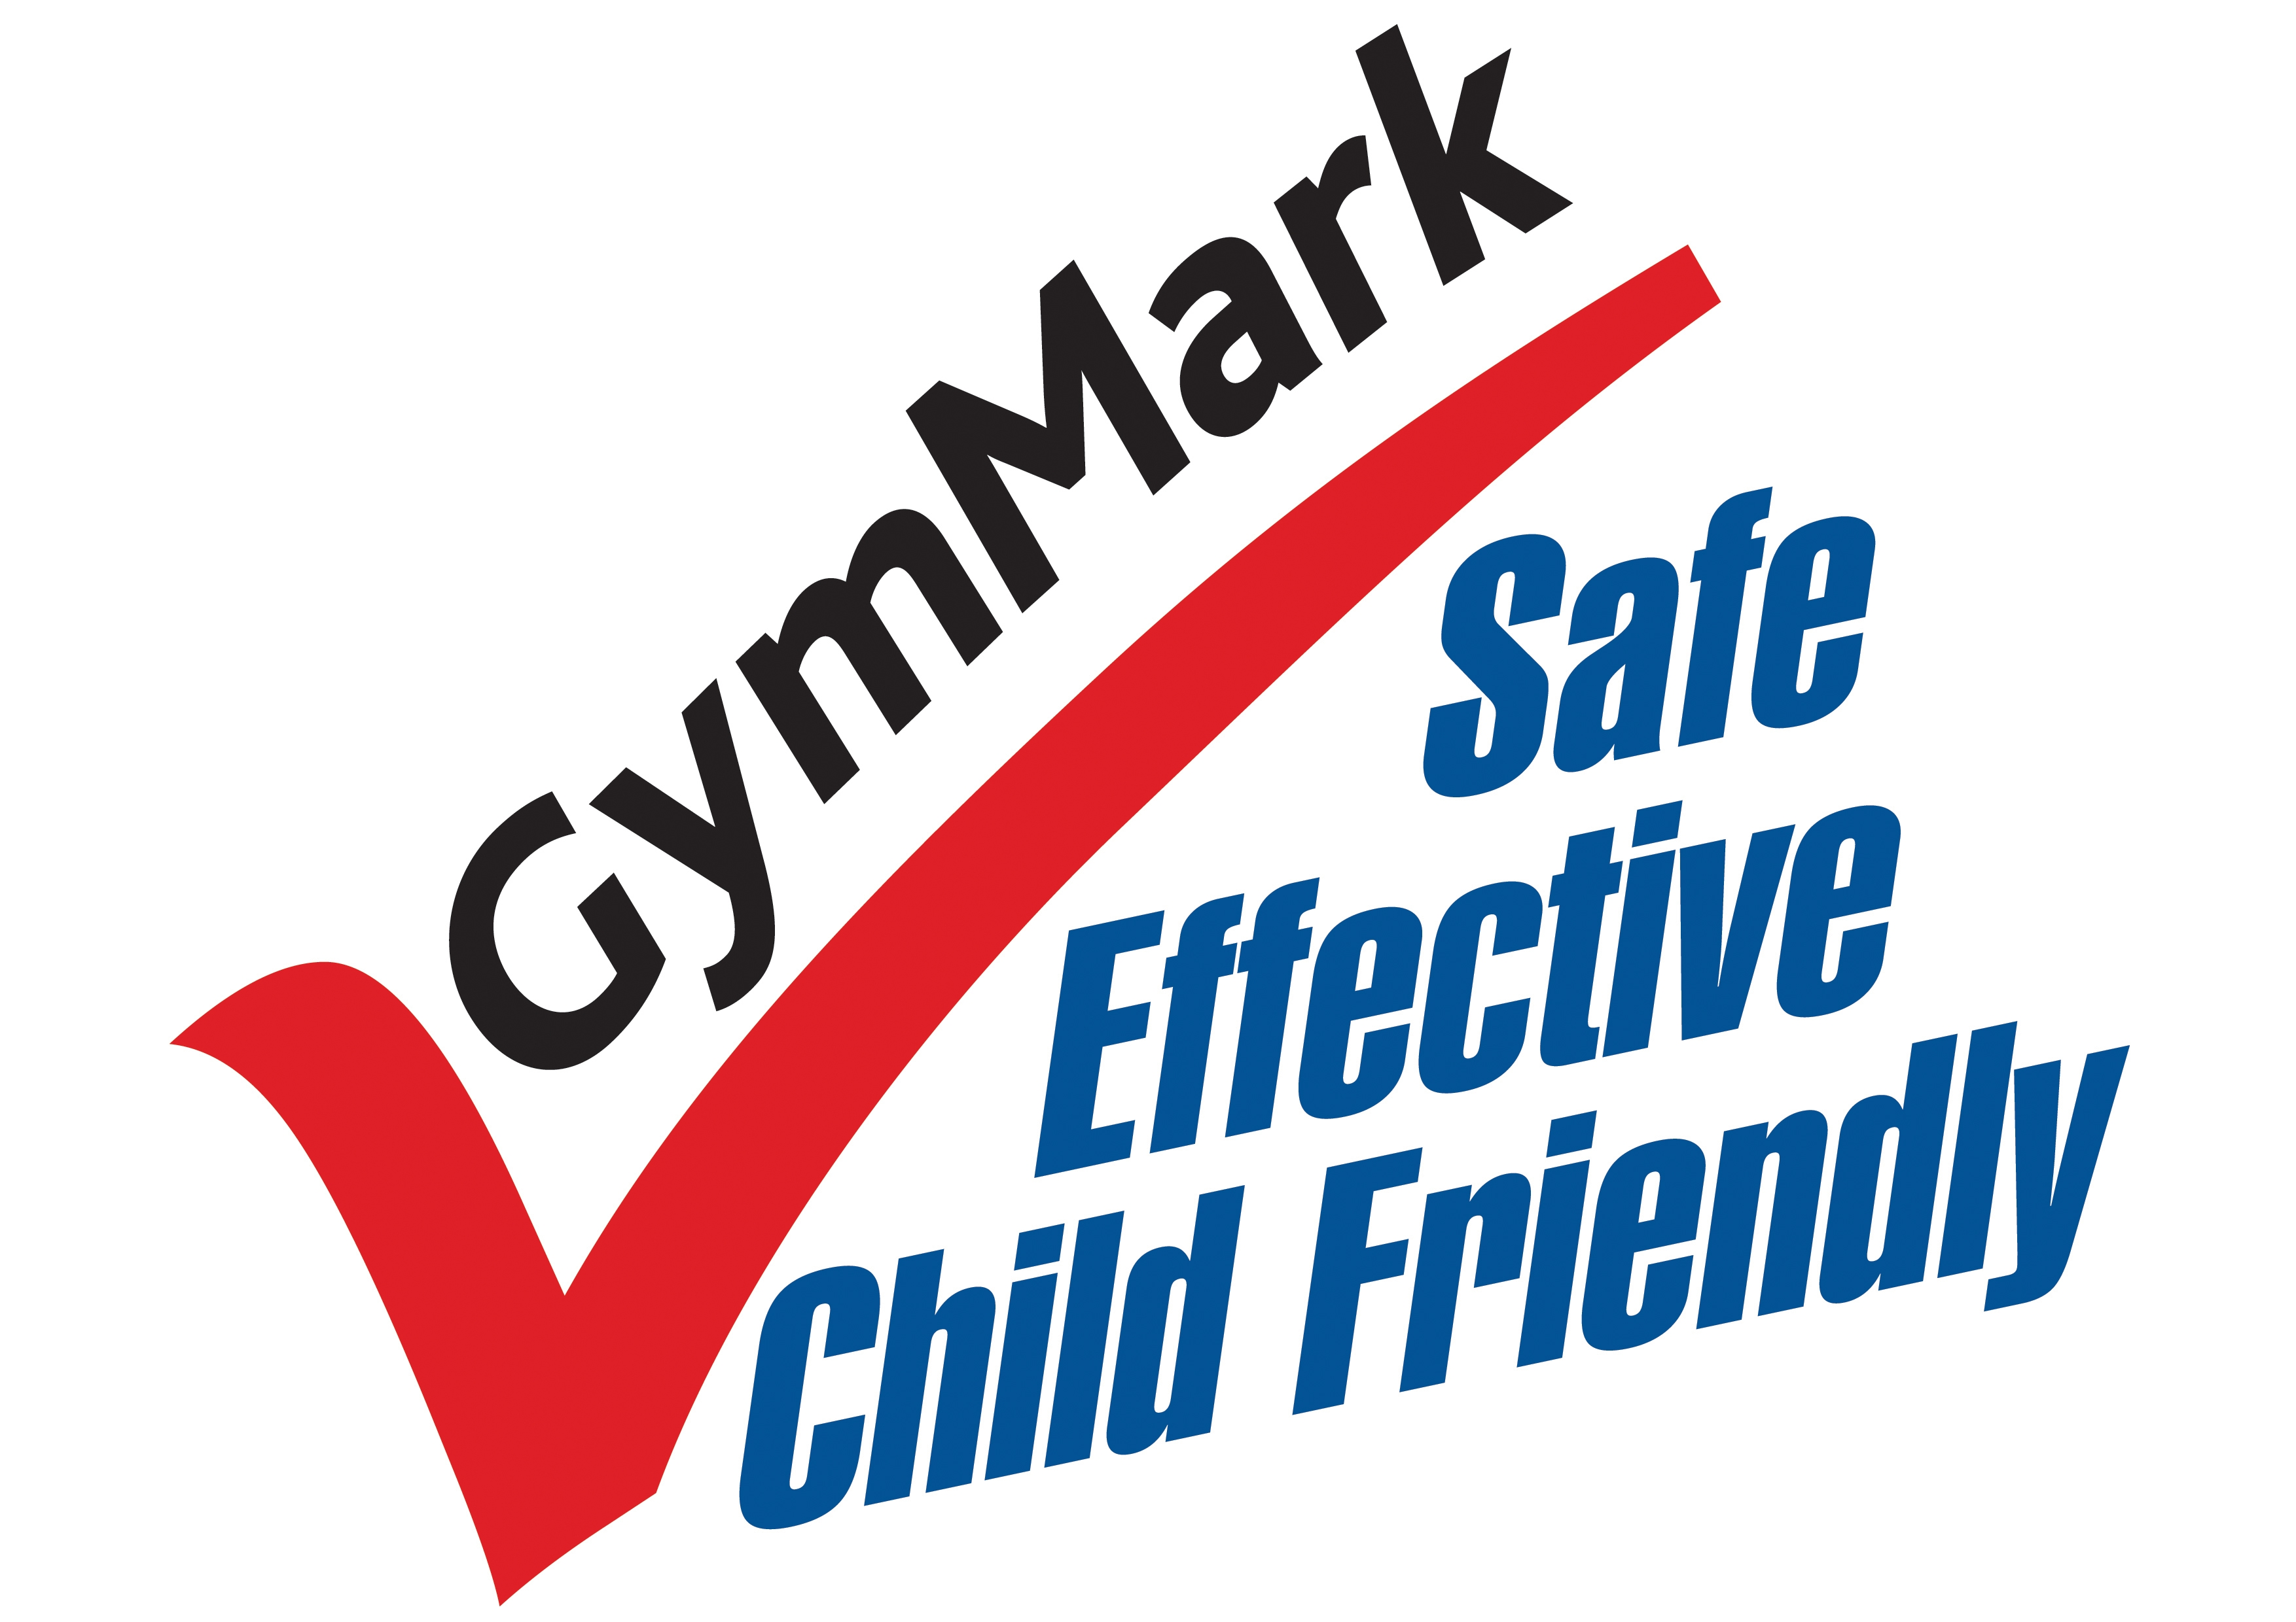
Head Coach  Name: Jessica Garrett  Mob: 07860668103  Email: JestersGymClub@aol.com | Youth Development  - Beginner gymnastics  - Boys gymnastics  - Intermediate gymnastics  - Jesters Squad  - Performers squad  - Tumbling squad
Welfare Officer  Name: Sam Durow  Mob: 07961081416  Heath/safety officer  Name: Mark Oakes-Heppelstone  Email: Markoakesheppelstone@  Mypostoffice.co.uk | Secretary/Memberships  Name: Mel Millard  Mob: 07867583479  Email: angelmels@aol.com
Treasurer  Name: Sue Garrett  Mob: 07719335614  Email: susanmart@hotmail.co.uk  - Course fees  - Accounts | Qualified Coaches  Jessica Garrett  Lily Garrett  Mel Millard  Mark Oakes-Heppelstone  Faye Skidmore  Rhianna Watson  Anne Grundy  Aiden Davison

Featherstone Sports Centre: 01977 722700
Club contact number: 07860668103
Club contact email address: JestersGymClub@aol.com
Find us on Jesters Gymnastics Club Facebook page, open to members only.



Jesters
Gymnastics Club



JESTERS, gymnastics for fitness, fun, and the ability to achieve.

NEW MEMBER HANDBOOK
Anti-bullying policy

The Head Coach will initially investigate incidents of bullying. In all proven incidents the complainant will receive support from Jesters Gymnatics Club ltd and disciplinary action will be taken concerning the bully.

If the individual does not respond to an informal approach, the Head Coach will meet with the individual and their parents and will issue and record a verbal warning. If the individual continues to bully, then the coach will inform Jesters Gymnastics Club ltd management, who will issue a written warning to the individual and their parents/guardians. With continued bullying Jesters Gymnastics club ltd Management will issue a second written warning. If the bullying does not stop, Jesters Gymnastics Club ltd Management will permanently exclude the individual from the club.

What is Bullying?
- Deliberate hostility and aggression towards a person(s).
- A victim who is weaker and less powerful than the bully or bullies.
- An outcome, which is always painful and distressing for the victim.

Bullying can be:
- Physical: Pushing, kicking, hitting, pinching and other forms for violence including threats.
- Verbal: Name-calling, sarcasm, derision, belittling, spreading rumours, persistent teasing.
- Emotional: Excluding (i.e. “sending to Coventry”) ridicule, humiliation, tormenting, (hiding possessions, threatening gestures)
- Racist: Racial taunts, graffiti, gestures.
- Sexual: Unwanted physical contact or abusive comments.

Persistent bullying can result in:
Depression Low self esteem
Under-achievement Isolation Shyness
Poor academic results Threatened or attempted suicide

Unchecked bullying also damages the bully who learns that he/she can get away with violence, aggression and threats and that this sort of behaviour gets them what they want. When children who are bullies carry on bullying as adults, they run into all sorts of problems.
Club terms and conditions

We ask that parents don’t sit in the gym during training sessions, this is for child safeguarding. There will be open sessions throughout the year where parents will be invited in to watch.

If your child misses three consecutive sessions without letting a coach know of their absence they will be removed from the register and added to the waiting list if they would like to return.

If your child cannot attend a session you as a parent/guardian must let a coach know NOT the gymnast.

An annual registration fee for membership to British Gymnastics is required and this encompasses appropriate insurance for your child and the club. This year’s membership is in three categories:
- 1 hour per week training £11
- Non-competitive Membership £17.
- Competitive Membership £41 (required for those entering competitions outside of the club)
This payment is included in your monthly fees for 1 hour per week , all other classes are required to complete their membership online through the British gymnastics website.

Payment for sessions are required up front monthly for all classes through Direct Debit through the Pay subs online system.

All classes must be paid for whether your child attends or not, certain cases may be exempt from payment at the discretion of the head coach.
These include:
- If your child has sustained a serious injury or illness and has been advised by medical professionals not to attend. (please provide evidence)
- If there has been a close bereavement in the family.
The club reserves the right to terminate any child’s participation in classes where fees are more than one month in arrears. Under these circumstances the child would have to re join the waiting list until a place became available and all arrears had been paid.
Background
- The club was formed in the early 90’s by Kath Shepherd, at Featherstone Sports Centre.
- The club was formed to give children of all abilities a chance to enjoy gymnastics, with the aim to enter elite gymnasts into competitions.
- We aspire to work the gymnast to their very highest capability, through lots of hard work and fun.
- The club is now run by Jessica Garrett, head coach since September 2015 and a team of 4 other directors, Mark, Mel, Lily and Faye.
Sadly, Kath Shepherd passed away in October 2010. However, the club strives on higher than ever, in memory of Kath’s hard work and dedication.
Our coaches
Jessica Garrett – Head coach (Director)
Jessica, an ex-Jester, is currently completing her level 3 Tumbling award, tumbling is an additional discipline and most beneficial to those whom attend. Jessica is also level 2 qualified in Sports Acro.
Lily Garrett (Director)
Lily Garrett is a level 2 Acro coach and level 1 Tumbling, also ex-Jester. She leads the performer class and the 4pm beginner classes as well as coaching in the jesters and tumbling classes. Lily is also the head choreographer.
Mark Oakes-Heppelstone (Director)
Mark is a level 2 Acro coach and level 2 tumbling coach, as well as a qualified Judge. Mark Leads the Jesters squad and boys beginner class.
Mel Millard (Director) is qualified to level 3 in Sports Acro and currently runs most of the beginner classes and the intermediate group. Mel was head coach at Jesters from 2010-2015.
Anne Grundy
Ex-Olympic gymnast, Level 2 Acro and Level 3 Artistic, helps us whenever possible. We are grateful for her expertise and knowledge.
Faye Skidmore (Director)
Is an ex jester who is now level 2 qualified in tumbling. Faye also coaches the performer class and our youngest beginner class.
Rhianna Watson
Has completed her level 1 Acro and helps out in the beginner and intermediate classes when she is back from uni.
Aiden Davison
Aiden is level 1 tumbling coach and helps out in the tumbling classes.
Helpers
Anna Knee, Phoebe Churm and Emily Thompson have completed their helpers award. We appreciate all their help they give to the club.
Code of Conduct - For Club Coaches, Officials and Volunteers

The essence of good ethical conduct and practise is summarised below. All Club Coaches, Officials and Volunteers must:-

- Consider the well being and safety of participants before the development of performance.
- Develop an appropriate working relationship with performers based on mutual trust and respect.
- Hold the appropriate, valid qualifications and insurance cover.
- Make sure all activities are appropriate to the age, ability, fitness and experience of those taking part and ensure all participants are suitably prepared physically and mentally when learning new skills.
- Display consistently high standards of behaviour and appearance, dressing suitably and not using inappropriate language at any time whilst involved with club activities.
- Never consume alcohol immediately before or during training or events.
- Gymnasts are the responsibility of the coach during training hours.
- Obtain prior agreement from the parent/guardian of performers before transporting them anywhere (training/competitions).
- Never have performers stay overnight at your home.
- Never exert undue influence over performers to obtain personal benefit or reward.
- Always report any incidents, referrals or disclosures immediately, following the appropriate guidelines set out in the BG Child Protection procedures.
- Never condone rule violations or use of prohibited substances.
- Make sure that confidential information is not divulged unless with the express approval of the individual concerned.
- Promote the positive aspects of the sport (e.g. fair play).
- Encourage performers to value their performances and not just results.
- Follow all guidelines laid down by BG and Jesters Gymnastics Club ltd.
If a coach, volunteer or official breaks a club rule they will be given a verbal warning, failure to comply a second time will result in a written warning which will be followed by a banning from the club if a coach, volunteer or official continuously fails to abide to Jesters club rules.

Code Of Conduct For Parents/Guardians
- Encourage your child to learn the rules and participate within them.
- Discourage challenging/arguing with officials.
- Publicly accept officials’ judgements.
- Help your child to recognise good performance, not just results.
- Set a good example by recognising good sportsmanship and Applauding the good performances of all.
- Never force your child to take part in sport.
- Always ensure your child is dressed appropriately for the activity (jeans are NOT suitable) and has plenty to drink - a bottle of water is recommended.
- Keep the club informed if your child is ill or unable to attend sessions, it is a parents responsibility to inform the club of any updates to their child’s registration and medical information form.
- Endeavour to establish good communications with the club, coaches and officials for the benefit of all.
- Share any concerns or complaints about any aspect of the club through the approved channels.
- Use correct and unaggressive language and tones at all times to all club officials, parents and gymnasts.
- Never punish or belittle a child for poor performance or making mistakes.
- Always pay fees promptly and respond to letters quickly.
- Always collect your child promptly at the end of a session and ensure they are brought in to the building at the start of the session.
- Support your child’s involvement and help them to enjoy their sport.
- Your child is not our responsibility once they have left the gym door at the end of training, if you want them to leave the gym alone/walk home you must provide us with a signed letter granting your permission, otherwise they will remain with a coach inside the gymnasium.(over 11’s only)

If a parent/guardian breaks a club rule they will be given a verbal warning, failure to comply a second time will result in a written warning which will be followed by a banning from the club if a parent or guardian continuously fails to abide to Jesters club rules.

Training Days (2018)

Beginner classes (Featherstone Sports Centre)
Mondays 16.00-17.00
17.00-18.00

Wednesdays 16.00-17.00
17.00-18.00

Saturdays 10:00-11:00
11.00 – 12.00

Boy’s beginner class (Featherstone Sports Centre)
Saturdays 09:00-10:00

Intermediate session (Featherstone Sports Centre)
Fridays 16:00-18:00

Performer squad (Featherstone Sports Centre)
Mondays – 18.00-20.00

Jesters Squad (Featherstone Sports Centre)
Wednesdays 18:00-20:00
Fridays 18:00-20:00

Tumbling squad (Carleton High School)
Saturdays 11:15-13:30
Thursdays 17.15 – 19.30



Child Protection Policy

Jesters Gymnastics Club ltd is committed to ensuring that those working with children and vulnerable adults adopt best practice to ensure the health, safety and welfare of the participants and staff.

The club will endeavour to promote the highest standards of care for all members, staff and officials by:

- The adoption of the BG Health, Safety and Welfare guidelines.

- The adoption of the BG guidelines for the Protection of Children and Vulnerable adults.

- The appointment of a Welfare Officer (Sam Durow) to whom grievances or complaints can be made confidentially.

- Ensuring that staff is suitably trained in Child Protection and Health, Safety and Welfare issues.

- Ensuring that coaches and officials have been screened to confirm their suitability to work with children. Where appropriate this will include Criminal Record Bureau disclosure.

- Ensuring that best coaching practice guidelines are followed at all times.

- Ensuring that grievances or complaints are dealt with promptly and in accordance with the grievance procedures.

- Ensuring that a minimum of two responsible adults are present at all training sessions or events.

- Ensuring that the participants and/or parents are aware of the purpose of videoing, filming or photography during training or events.

- Having a zero tolerance level for poor practice, bullying or any potential form of abuse.

Code Of Conduct - For Participants

We are fully committed to safeguarding and promoting the well-being of all our members. The club believes it is important that members, coaches, administrators and parents associated with the club should, at all times, show respect and understanding for the safety and welfare of others. Therefore, members are encouraged to be open at all times and share any concerns or complaints that they may have about any aspect of the club with the Welfare Officer.
As a member of Jesters Gymnastics Club ltd you are expected to abide by the following club rules:
- All members must participate within the rules and respect coaches, judges and their decisions.
- All members must respect fellow club members and opponents.
- Members should keep to agreed timings for training and competitions or inform their coach if they are going to be late. It is essential not to miss training days, anyone missing Friday training before the weekend display will not be allowed to perform, as placements are set in routines.
- Members must wear suitable attire for training and events as agreed with the coach. Keep all long hair tied back. Remove all body jewellery, including earrings.
- Members must not smoke, consume alcohol or take drugs of any kind whilst representing the club at competitions or other events.
- Members must inform the head coach of any injuries or illness they may have before the warm-up begins.
- If a member continuously fails to keep up with the fitness and technicality of a class they may be asked to try a different class more suited to their ability.
- Members should not eat or chew gum during a session.
- Members must not use inappropriate language.
- Members should remain with coaches at the end of a session until collected by their parent or guardian.
- Members must not under any circumstance leave the gymnasium without the permission of a coach.
If a member breaks a club rule they will be given a verbal warning, failure to comply a second time will result in a written warning which will be followed by a banning from the club if a member continuously fails to abide to Jesters club rules.

